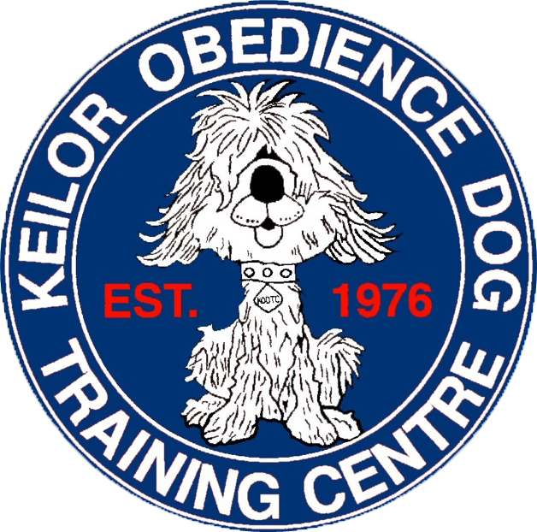
Keilor Obedience Dog Training Centre Inc.


P.O. Box 75, Niddrie, VIC 3042 kodtc12@gmail.com www.kodtc.com.au
A0009795X

Keilor Dog Obedience Training Centre (A9795X)
Annual General Meeting – 10.30am, November 23rd 2025

AGENDA
1. Open Meeting
2. Apologies
3. Minutes of previous AGM
4. Business arising from the previous AGM
5. President’s Report
6. Treasurer’s Report
7. Auditor’s Report
8. General Business: -
9. Nomination of Auditor for 2025-2026
10. Election of Club Committee for 2025-2026
At 5 October 2025 the following nominations were received and are elected unopposed:
President – Joy Allen
- Vice President
- Treasurer- Drew Harrison
- Secretary

Committee – Sylvana Sabato, Maree Schellekens, Rachael Marszalek, Anne Woolley, Max Schellekens, Michael Haigh, Rob Youdan, Jim Vavaroutsos, Lily Vavaroutsos, Rohan Richardson, Carol Di Teodoro, Julie Merryful

11. Close Meeting

